**Circulatory / vascular System**

* **Aorta => artery => arteriole => capillary => venule => vein => vena cava**
  + End goal is capillary exchange
* **Microcirculation**: arterioles, capillaries, and venules; within organs
* Rest: digestive 27%, kidney 20%, brain 13%, muscles 15%
* Exercise: digestive 5%, kidney 4%, brain 13%, muscles 64%

**Blood flow**

* Text

  Description automatically generated**Flow rate**: volume of blood passing / time, pressure / resistance or velocity / area
  + **Pressure gradient**: towards lower pressure vessels
  + **Resistance**:
    - **Radius**:
      * Main determinant, vasodilation and vasoconstriction
    - Length:
    - Viscosity of blood: , viscosity primarily determined by # of RBCs

**Vessel Anatomy:**

* **Multi-unit smooth muscle**: smooth muscle => **not striated**, has **tone**, more **economic**
  + **Neurogenic**, contract only when stimulated
  + Act as **independent units** (single cell or motor units), few gap junctions
  + Various configurations:
    - **Sheets** (walls of blood vessels)
    - **Bundles** (iris)
    - **Single cell** (capsule of spleen)
* 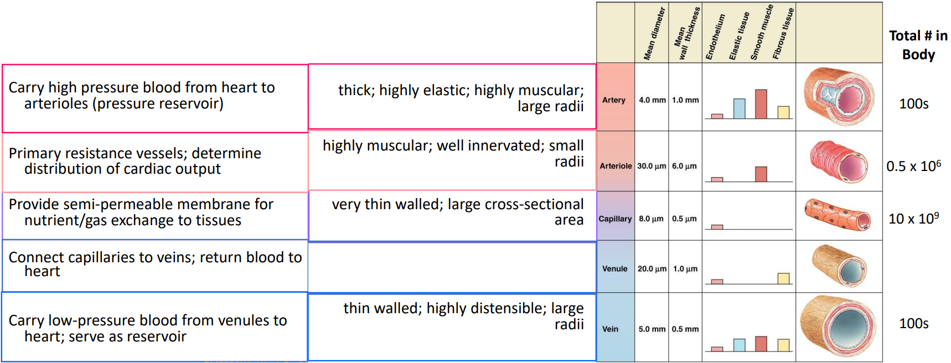Tunica adventitia (**connective tissue**) > external elastic lamina (elastic fibre) > tunica media (**smooth muscle**) > internal elastic lamina > tunica intima (**endothelial**)

**Arteries**

* 2 main functions:
  + **Rapid-transit**: large radius => little resistance
  + **Pressure reservoir**: many elastic fibers (balloon like), provides driving force for blood when heart is relaxing
* **Blood pressure**: depends on distensibility (stretchability), **pulsatile** from elasticity
  + **Systolic** (max ~**120** mmHg): only **1/3** blood entering arteries go to arterioles
  + **Diastolic** (min ~**80** mmHg): no blood entering arteries but still leaving
  + **Pulse pressure**: pressure difference (why you fell pulse),
  + **Mean arterial pressure**: average pressure, in systole,
    - Specifically, MAP = **cardiac output** (CO) * **total peripheral resistance**
* **Diagram

  Description automatically generated**Diagram

  Description automatically generated with low confidence**Sphygmomanometer**: detect when Korotkoff (turbulent) sounds appear/disappear

**Arterioles**

* **Major resistance vessels** (much smaller radius)
  + Lowers pressure to maintain pressure gradient
  + Converts pulsatile pressure to **non-pulsatile** (not elastic)
* **Variable radius** (little elastic, thick smooth muscles)
  + Vary distribution of blood between organs
  + Text

    Description automatically generatedRegulates arterial pressure
* **Vasoconstriction** and **vasodilation**: SNS, chemical changes, hormone
  + **Vascular tone**: baseline state of partial constriction
  + **Intrinsic** (local) control: chemical and physical
    - **Endothelial cells**: respond to chemical and physical changes, release local vasoactive mediators which act on smooth muscles
      * **Nitrate oxide** (NO): inhibit Ca, vasodilation
      * **Endothelin**: vasocontraction
      * Some are long term
      * Some triggers **angiogenesis** (new vessel growth)
    - Chemical triggers:
      * Local metabolic changes (alters local chemicals)
        + **Active hyperaemia**: dilation for cells metabolically active (acid (lactic, carbonic))
      * **Histamine** (not by endothelial) - vasodilation in injured area
    - Physical triggers:
      * Local change in **temperature** (clinical usage)
        + Heat – dilation, cold - contraction
      * **Shear**: friction of blood on endothelial cells => release NO
      * **Autoregulation** (Myogenic response): more blood => stretch => strength increase => contraction => less blood, vice versa
        + **Reactive hyperaemia**: dilation respond to blockage (chemical build up and no stretch)

**Capillaries**

* Extensively **branched** vessels with **small radii**
  + Parallel connection with small radii minimizes resistance
  + Maximized **surface area**, minimize **resistance** and **diffusion distance**
  + **Low velocity** of flow (10 mm/s)
* Single layer of **endothelial** cells
* Surrounded by **precapillary sphincters**: rings of smooth muscle at beginning of vessel
  + Resting: many capillaries are closed
* **Metarterioles**: surrounded by smooth muscle and run between **arteriole** and **venules** (instead of capillary), no gas exchange occurs, shunt only for homeostatic regulation

**Veins**

* **Blood reservoir** / capacitance vessels, **volume control**
  + large radius, little resistance, low pressure
  + highly distensible with little elastic recoil (little elastic, many collagen)
* Venous capacitance: blood in veins
* Venous **valves**: around muscles in veins, prevent backflow & counter gravity
* \***Venous return**: blood entering each atrium per minute, 1/capacitance, 5 factors
  + **Vasoconstriction** (SNS): increase return => increase flow (opposite from artery)
  + Blood volume: more blood = more return
  + Skeletal muscle pump: muscle contraction constricts veins, counter gravity
  + Venous valves: around muscles in veins, prevent backflow & counter gravity
    - Varicose veins: incompetent valves, blood pool in veins
  + Respiratory pump: lowered chest pressure from breathing enhance return
  + Cardiac suction: ventricular contraction lower atrial pressure (+ return)

**Regulating Blood Pressure**

* 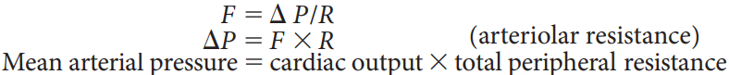The blood pressure monitored and regulated in the body is **mean arterial pressure**
  + must be high enough to ensure sufficient driving pressure
  + must not be so high to creates extra work for the heart and increases the risk of vascular damage / rupture of small blood vessels
* **Short-term control**: mediated by ANS, adjustments made by alterations in cardiac output and total peripheral resistance (heart faster, veins/arterioles constrict)
  + **Epinephrine** & **norepinephrine** reinforce SNS
* **Long-term control**: total blood volume adjusted by restoring normal salt and water balance through regulating urine output and thirst (increase fluid &/ viscosity)
  + **Vasopressin** (ADH): maintain water balance by regulating urine formation
    - High level => less urine & some vessel constriction => raise BP
* **Baroreceptor**: blood pressure regulation
  + Receptors: **carotid sinus** (on vessels to brain) and **aortic arch** (at start of aorta) baroreceptors detects mean arterial pressure and pulse pressure
  + Frequency of firing **AP BP**
  + **Negative feedback**: As pressure decreases, sensory nerve signals decrease and cardiovascular control center respond by increasing SNS activity
* **Chemoreceptors**: detect oxygen in arteries,
  + Receptors are in similar location to baroreceptors: **carotid body** (to brain) and **aortic body** (aorta)
  + Sense O2, CO2, and H+
  + Increased CO2 increase respiratory rate, HR and force of cardiac contraction
  + Increased O2 stimulates vessel growth
* **Cardiovascular control centre** (medulla in brain stem, integrating center)
  + Controls ratio between SNS and PNS
    - SNS **constrict** vessels for **pressure**, except in brain & heart
      * Has a baseline tone (decrease SNS is dilation)
      * Direct distribution of blood while maintaining pressure
        + Actual dilation (skeletal/cardiac) is local (**override SNS**)
  + **Arterioles** and **veins** exhibit a dense supply of nerves
  + **Hypothalamus**: controls blood flow to skin to adjust heat loss to environment, long-term regulation of blood pressure by adjusting plasma volume
  + Associated with certain behaviors and emotions mediated through cerebral hypothalamic pathway??